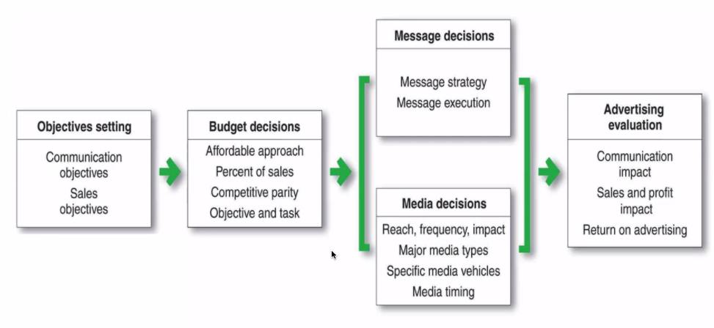
Promotion

Ad Objectives
- Informative advertising
  - Communicating value – explaining how product works
  - Building band image
  - Suggesting new product uses, correcting false impressions about product
  - Most useful when consumers are at the information gathering stage
- Persuasive advertising to induce consumption
  - Build brand preferences, encouraging switch to your brand. Persuading customers to purchase now, to tell others about the brand etc.
  - Useful when customers are at the compare stage of the consumption funnel
- Reminder advertising to maintain customer relationships
  - Keep brand in mind during off-seasons, remind customers where to buy product
  - Useful when consumers are in the review stage of consumption

Budget decision
- Affordable method – advertise spending as a proportion of what is an affordable marketing budget
- Percent of sales method – percent of sales revenue is ad budget
- Competitive parity method – look at competitors’ spending level (absolute or sales %)
- Objective and task method
  - Define objectives
  - Determine tasks necessary to achieve objectives
  - Estimate cost of performing these tasks
  - Most accurate but least used as hard to pin down the tasks
- Research shows S-shaped relationship between marketing effort (spend) and effectiveness (sales). Threshold point, strong relationship then diminishing returns set in.
  - Should inform advertising spend

Message decision
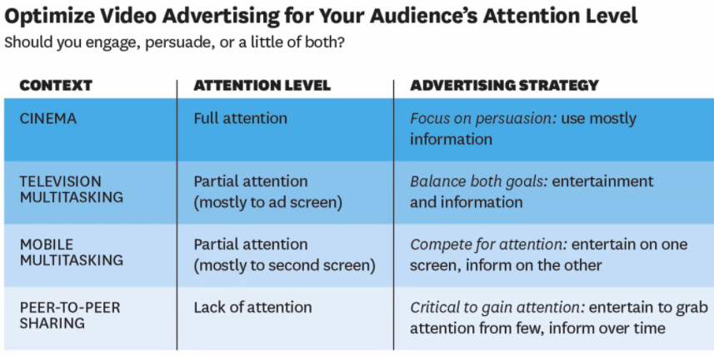
- How to design an ad in different contexts.
- Have to find sweet spot between too boring and too entertaining. Entertaining distracts.
  - Entertainment should be presented after the brand name

Media decision
- Nowadays so many mediums through which we can advertise.
  - Digital advertising now larger than TV

Digital advertising
- SEO – organic searches. Companies don’t need to pay for these
- Paid – ads which companies pay to rank at the top of searches

Display advertising
- Visit website (known as a publisher) which might display ads. How are these slots sold to advertisers?
- Publishes provide their available ad slots to an ad network, which matches inventory to advertisers. Ways to pay:
  - Cost per click, or per thousand
  - Cost per ad displayed
- Mechanisms to pay include real time bidding, or fixed price.
  - Advertisers willing to pay highest price for the slot will win it. Completed in seconds.
  - Should publisher consider what customers want to see?

Search advertising
- Sponsored search (top of searches, pay for clicks)
  - Choose key words – general or specific? Depends on cost and buyer motivation
    - Geo-targeting by IP address and language
  - Bid for word – winning is a function of relevance and clicks
- Organic searches (don’t play for click)
  - Sometimes not useful to purchase keyword of your brand as people searching it would click on the organic search anyway
Google scoring ads – expected user clickthrough rate, ads landing page experience, ad relevance (analysing ad language relevance to search query)

Advertising evaluation
- Increase in digital advertising – are they spending too much? P & G cut additional ad spend, saying it was wasteful.
  - Ads may not be seen by actual people e.g. bots initiated by competitors
  - Maybe content is not appropriate (right webpage or device)
  - Value of a multi-channel approach

So how do we assess ad effectiveness?
- Attitude and awareness objectives can be assessed by comparing pre-promotion levels and post-promotion awareness levels. Useful for informative ads.
  - Google trend is one way to measure the awareness objective (shows search volume of key words, can be specified geographically too).
  - Comparing relative search volume of different words can show secondary demand (if not primary demand).
- Behavioural objectives are harder to measure
  - Change in sales is a noisy measure – hard to know what proportion of the change is attributable to advertising
    - Impacted by other factors like attention level of consumers, legitimacy, competitors’ spending, cost of a campaign, how well targeted each ad is, whether you are reaching customers at the right moment of their decision process
  - Ad exposure is not random – high correlation between spend and sales because firms advertise to customers most likely to respond, and when they are most likely to buy.
    - Many customers would buy even if they didn’t see the ads
  - Ad attribution – ads appear on several sites, which one led to the sale?
    - Last touch advertising – click right before purchase considered to be the one leading to the purchase. May undervalue previous ads.
  - Tests in new markets are more effective
- Experiments are best way to measure ad effects
  - A/B testing is a form of distribution which gives website visitors different treatments (website A and website B).
  - Measure and compare responses across groups (click-through rates)
  - Use this to decide the most effective treatment / website design

Why many firms don’t experiment
- Expensive, particularly for smaller firms who need to collect a lot of data which is needed for precise estimations

Fisman, R. (2013)
- Companies advertise heavily at times when and in areas where they expect sales to grow, so hard to measure the impact of these ad expenditures. Advertising is traditionally wasteful, but the internet promised to change that through targeted advertising.
  - Advertises are only charged for paid search listings that get clicked on
- eBay team has been examining whether there’s any benefit to buying search ads containing the word Ebay. In the absence of these paid listings, consumers might still click on the unpaid eBay listings which would appear at the top of the search anyway. They stop purchasing ad searches on Microsoft and Yahoo but kept them for Google. No change – customers simply substituted clicks on unpaid search listings for the now-absent paid ones
- Next step was shutting off Google ad searches in a third of the country but continued to buy ads everywhere else. On aggregate, no change. Found that paid search ads serve an informational function for a minority of customers with little recent history of eBay transactions. Overall paid search was an expensive way of attracting new business.
- Marketing departments should be more careful not to confuse causation with correlation in assessing the returns to their ad expenditures. Paid search ads may be worth it for smaller companies lacking the high Google page rank which make paid searches less valuable for eBay, Amazon etc.

Katona, Z. and Bell, B. (2017)
- Rocket fuel aims to transform digital advertising industry through big data and artificial intelligence. Became industry leader by bringing precision and conclusiveness of science into marketing to drive a higher ROI. By 2016 they had revenue of $500m.
- TaskaBella asked Rocket Fuel to run a trial campaign for a newly released handbag model. Main concern is reaching sufficiently high levels of conversion rates so that advertising dollars lead to enough purchases to justify the spend.
- CPMs (cost per thousand impressions) affected by many factors, but with the target sites and population here, it is estimated at $9 per thousand impressions, and converting a user is worth about $40 (margin).
  - Data: CPM of $10 translates to a cost of roughly $10-15 per conversion.
  - However, manufacturer already had a strong social media presence and word of mouth publicity. So control group used (random ads v TaskaBella) to assess how many conversions can be attributed to the campaign
- By the end of the campaign, 14.5m impressions were served at an average CPM of $9. Out of 590,000 users identified, 15,000 bought the new handbag. Total costs of advertising was compared to the value of conversions to understand profitability and ROI.

Lecture notes
- Attribution problem – confounding variables like large social media following
- So they ran experiments

Consumer heterogeneity and paid search effectiveness (Blake, 2015)
- Based on results from eBay experiment. Internet advertising has grown disproportionately, and search engine marketing (SEM) remains the largest format by revenue, accounting for 46% of 2021 revenues. Experiments show effectiveness of SEM is small for large firms like eBay, but has a positive effective on new user acquisition and influencing purchases by infrequent and less recent customers.
  - Supports informative view of advertising – targeting uninformed users is critical
- Internet marketing solved the long-standing dilemma of wasting dollars on infra-marginal consumers to reach marginal consumers who will be affected by ads.
  - Endogeneity challenge where many customers clicking on ads are loyal and would have found other channels to visit the company’s website.

Johnson et al (2017)
- Campaigns increase site visits and conversions, with median lifts of 17% and 8% respectively. This paper investigates whether these in-campaign lifts carry forward after the campaign or only cause users to take action earlier than they otherwise would have. Find that most have a modest and positive effect 4 weeks after the campaign, further 16% lift in visits (from a 6% lift in visitors).
- Then relates the baseline attrition as customers move down the purchase process (the marketing funnel) to the incremental effects of ads on the consumer process purchase (ad effectiveness funnel). A 10% lift in site visitors translates to a 5-7% lift in converters.
- Strong evidence that online display adds increase site visits and conversions. Variability in ad effectiveness, median lifts described above.
  - Variability in ad effects and relationships are a natural consequence of different advertisers from different industries having different advertising goals and measuring different outcomes.

